**CSCI 6010 Programming Assignment #6**

**Student: Shifeng Yuan GWid: G32115270**

To run this program, we should first define how many banks are included which is represented by “n” and what is the certain limit which is represented by “limit”, in this case, let’s define n as 5 and limit as 201:

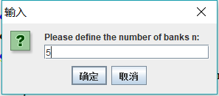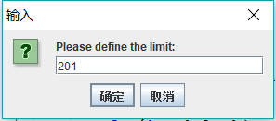

Then we need to tell the program the balances of each bank respectively:

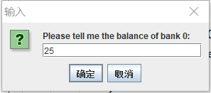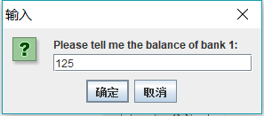



…......

After that, we define the loans from bank “i” to bank “j”:

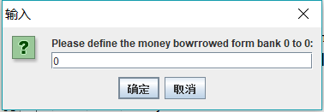

(A bank never borrow money from itself, so the loan is defined as 0)

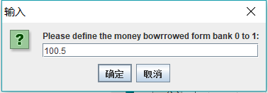

……

……

After the processing, we finally got the result:

Unsafe banks are bank 3 and bank 1.

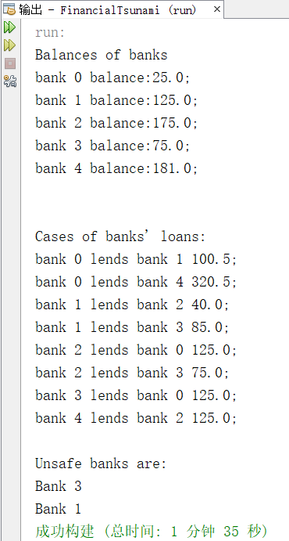

Thank you for reviewing my homework!